**COMSATS University Islamabad, Abbottabad Campus**

**Department of Computer Science**

**Project Proposal**

**Bank Management System**

**CSC392 Object Oriented Software Engineering**

Submitted on: <24/04/22 >

Group Members:

Ahmed Bin Khalid (FA20-BSE-062)

Zain Asif (FA20-BSE-136)

Hassan Javed (FA20-BSE-143)

Rahim Durrani (FA20-BSE-050)

Muhammad Hashir (FA20-BSE-079)

Ghulam Abbass (FA20-BSE-053)

Mubashir Ahmed (FA20-BSE-063)

…

Table of Contents

CHAPTER 1 PROJECT PROPOSAL 3

Introduction 3

Vision and Business Case 3

Use-Case Model 3

Supplementary Specification 3

Glossary 3

Risk List & Risk Management Plan 3

CHAPTER 2 USE CASES 4

Use Case Diagram 4

Brief Level Use Cases 5

ZAIN ASIF (FA20-BSE-136) 5

Use Case 1: Deposit Funds 5

Use Case 2: Deposit Cash 5

Use Case 3: Deposit Cheque 5

Use Case 4: Withdraw Money 5

Fully Dressed Use Cases 6

ZAIN ASIF (FA20-BSE-136) 6

Use Case UC 1: Deposit Funds 6

Use Case UC 2: Deposit Slip 9

Use Case 3: Deposit Cheque 12

Use Case UC4: Withdraw Money 15

Rahim Khan [ 050] 18

**Use case name:** Insurance 18

# CHAPTER 1 PROJECT PROPOSAL

## Introduction

[Text Book: 3.3. Case One: The NextGen POS System]

## Vision and Business Case

***Describes the high-level goals and constraints, the business case, and provides an executive summary.***

[Text Book: 7.6. NextGen Example: (Partial) Vision]

## Use-Case Model

Describes the functional requirements. During inception, the names of most use cases will be identified, and perhaps 10% of the use cases will be analyzed in detail.

## Supplementary Specification

***Describes other requirements, mostly non-functional. During inception, it is useful to have some idea of the key non-functional requirements that have will have a major impact on the architecture.***

[Text Book: 7.4. NextGen Example: (Partial) Supplementary Specification]

## Glossary

***Key domain terminology, and data dictionary.***

7.8. NextGen Example: A (Partial) Glossary

## Risk List & Risk Management Plan

***Describes the risks (business, technical, resource, schedule) and ideas for their mitigation or response.***

* + For example, leadership really wants a demo at the POSWorld trade show in Hamburg, in 18 months. But the effort for a demo cannot yet be even roughly estimated until deeper investigation.
  + For example, in the NextGen POS, for what remote services (e.g., tax calculator) will fail-over to local services be allowed? Why? Do they provide exactly the same services locally as remotely, or are there differences?

# CHAPTER 2 USE CASES

## Use Case Diagram

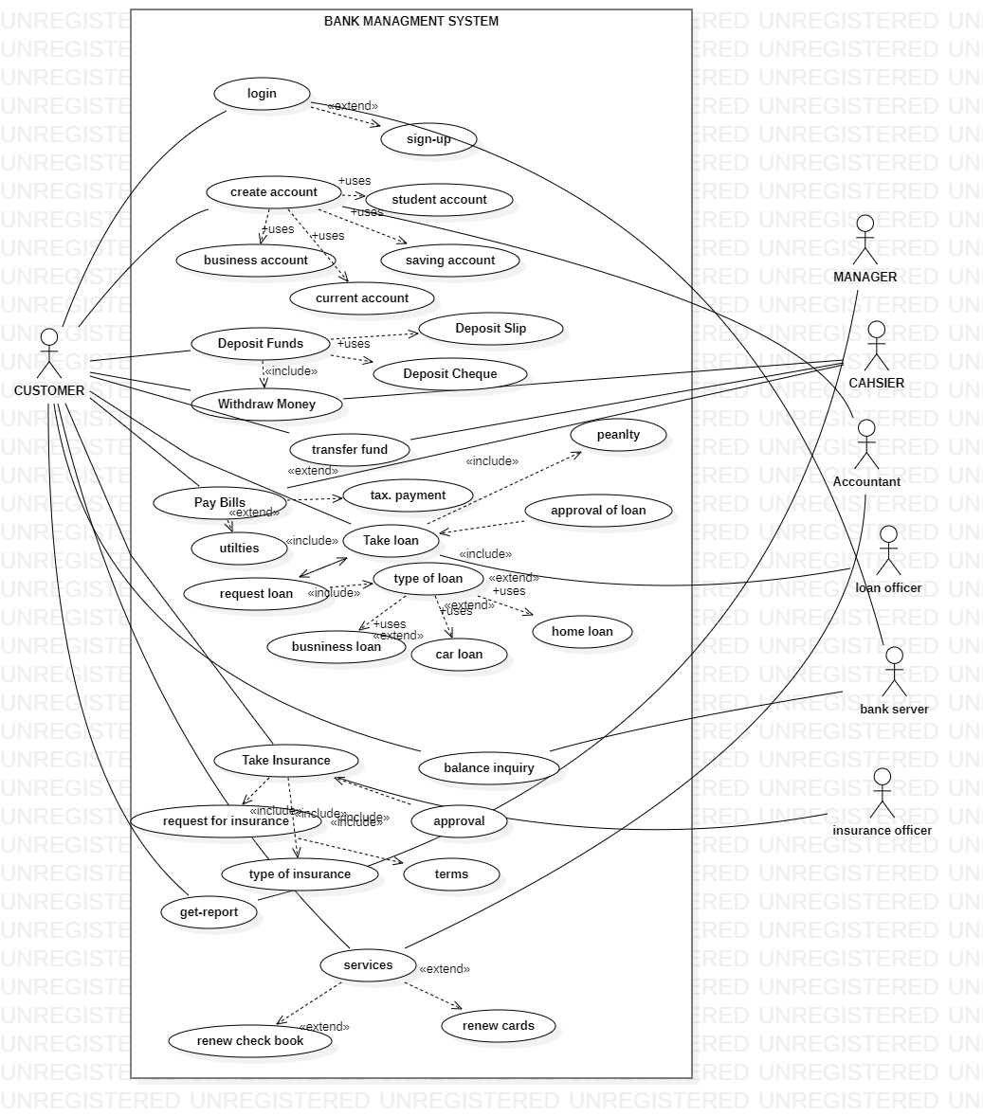

## Brief Level Use Cases

### ZAIN ASIF (FA20-BSE-136)

### Use Case 1: Deposit Funds

A customer arrives at a bank with money to deposit. The cashier uses the Banking Management System to record each transection of deposited money. The system presents a running total deposited money. The Customer provide his/her information. The Cashier enters account information, which the system validates and records. The system updates transection. The customer receives a receipt from the system and then leaves the bank.

### Use Case 2: Deposit Cash

A customer arrives at a bank with money to deposit. As the bank have already provided him with the facility of deposit slip .The cashier uses the Banking Management System to record each transection of deposited money the Customer will fill his/her deposit slip .Customer will hand-over the slip to the cashier, the cashier will recount the money to verify the amount is correct. The system validates and records. The Customer has successfully deposited money in his account through slip. . The customer receives a receipt from the system and then leaves the bank.

### Use Case 3: Deposit Cheque

A customer arrives at a bank with money to deposit. As the bank have already provided him with the facility of deposit money by cheque. The cashier uses the Banking Management System to record each transection of deposited money the Customer will fill his/her deposit Cheque .Customer will hand-over the Cheque to the cashier, the cashier will recount the money to verify the Cheque and money. The system validates and records. The Customer has successfully deposited money in his account through Cheque. . The customer receives a receipt from the Bank and then Customer leaves the bank.

### Use Case 4: Withdraw Money

A customer arrives at a bank to withdraw money. The cashier uses the Banking Management System to record the withdraw process. The system presents a user detail and total money in account. The Customer provide his/her information. The Cashier enters account information, which the system validates and records. The system updates transection. Customer successfully withdraw money. The customer receives a receipt of transection from the system and then leaves the bank.

Student Name 2 (Registration Number 2)

Student Name 3 (Registration Number 3)

## Fully Dressed Use Cases

### ZAIN ASIF (FA20-BSE-136)

| | Use Case UC 1: Deposit Funds | | --- | | **Scope**: Banking Management System  **Level**: The Customer goal is to deposit money. It could be through deposit slip or Cheque Book.  **Primary** **Actor**: Customer ,Cashier | |
| --- | --- | --- |

**Success Guarantee** (or Post conditions):

Deposit money is saved. Deposit money is correctly calculated and deposited. Customer account is updated. Receipt is generated. Deposit authorization approvals are recorded.

**Main Success Scenario (or Basic Flow):**

1. Customer arrives at bank to deposit.
2. Cashier starts a new payee.
3. Customer provide his/her information.
4. Cashier enters Customer information.
5. Cashier repeats counting deposited money.
6. System presents total with previous money in account.
7. Cashier tells Customer the total.
8. System records deposit process.
9. Cahier Generate receipt and gave it to Customer.
10. Customer get receipt.
11. Customer leaves the bank.

**Extensions (or Alternative Flows)**

*a. At any time, System fails:

To support recovery and correct accounting, ensure all transaction sensitive state and events can be recovered from any step of the scenario.

1. Cashier restarts System and requests recovery of prior state.
2. System reconstructs prior state.

2a. System detects anomalies preventing recovery:

* 1. System signals error to the Cashier, records the error, and enters a clean state.
  2. Cashier starts a new payee.

*b.Money is deposit without a detail:

Will we develop some conditions that puts each deposit in some kind of wrapping?

1. If the Customer deposit without a customer details, the top payment will be marked with the account number.
2. The Customer only provide the his account id to deposit money in account

*c.Other Currency is Deposit

Deposit other currency in bank account. If the Bank Customer deposit other currency it can’t detect it. Your country currency will be marked and the others not.

1. To deposit foreign currency in your account you need to deposit foreign currency.
2. Our system provide the facility to deposit any currency in money it will automatically change into your country currency.

**Special Requirements:**

* Process authorization response within 40 seconds 70% of the time.
* Language internationalization on the text displayed. E.g. Urdu, English etc.
* Touch screen UI on a large flat panel monitor. Text must be visible from 10 meter.
* Only one customer can deposit money at a time.
* If system crashes it will automatically restart within 30 second.

**Technology and Data Variations List**:

* The Deposit money is counted by banknote Counter.
* Identified Currency by FoxPro software.
* Customer always use the biometric finger print scanner to verify the transection every time he /she deposit money.
* Deposit Money through third party system.

**Open Issues:**

* What are the taxes that will apply on my account through the year?
* Explore the remote service recovery issue.
* Must a cashier take their cash drawer when they log out?
* Can the Other customer directly use the system to deposit money, or does the accountant have to do it?

**Screen Shots:**

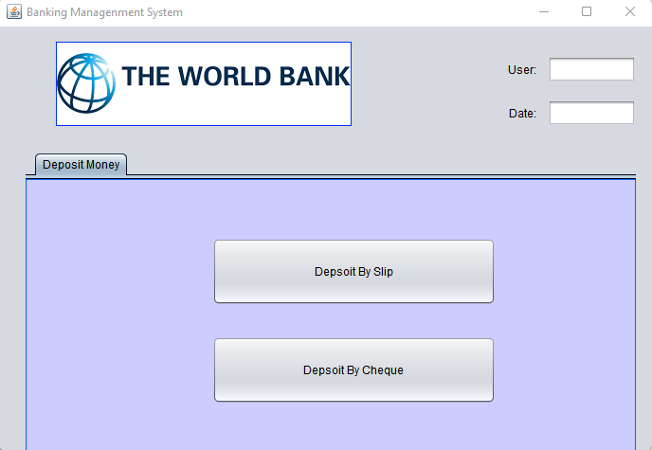

| | Use Case UC 2: Deposit Slip | | --- |   **Scope**: Banking Management System  **Level**: The Customer successfully deposit money in his account through deposit slip.  **Primary** **Actor**: Customer ,Cashier  **Stakeholders and Interests**:   * Cashier: Wants accurate, fast entry, and no deposit Payment errors, as cash drawer shortages are deducted from his/her salary. * Customer: Wants deposit and fast service with minimal effort. Wants easily in depositing money in his account. Wants proof of payment to support his side. * Bank Manager: Wants to accurately record transactions and satisfy customer interests. Wants to ensure that Payment Authorization Service payment receivables are recorded. * Maintenance: Wants to be able to quickly perform override operations, and easily debug Cashier, accountant, manager problems. * Bank Server: Wants to receive correct digital transection requests in the correct format and protocol. Wants to accurately store the transection history in the server.   **Preconditions**:  Customer must have a Bank account to deposit money and Cashier is identified and authenticated. |
| --- | --- |

**Success Guarantee** (or Post conditions):

Deposit money is saved. Deposit money is correctly calculated and deposited. Customer account is updated. Receipt is generated. Deposit authorization approvals are recorded.

**Main Success Scenario (or Basic Flow):**

1. Customer arrives at bank to deposit money.
2. Cashier starts a new payee.
3. Customer enters Customer information in a deposit slip.
4. Customer gave slip to cashier.
5. Cashier counted deposited money
6. System records deposit process and presents total with previous money in account.
7. Cashier generate receipt.
8. Customer get receipt and leave the bank.

**Extensions (or Alternative Flows):**

*a. At any time, System fails:

To support recovery and correct accounting, ensure all transaction sensitive state and events can be recovered from any step of the scenario.

1. Cashier restarts System and requests recovery of prior state.
2. System reconstructs prior state.

2a. System detects anomalies preventing recovery:

* 1. System signals error to the Cashier, records the error, and enters a clean state.
  2. Cashier starts a new payee.

*b. Money cannot deposit with Wrong detail:

If the Customer deposit with wronged customer details, the top payment will not be marked.

* Money cannot be deposit if the customer is not given the proper detail of his accounts. To solve this the system must gave the user another slip the rewrite the information again

1. The System must open his domain open for all type of given information I.e.
2. Customer Name Must be of 15 Character.
3. Write the Correct Date.
4. Authorize your slip with the sign of accountant.

*c. Accountant Sign:

If the accountant sign is not present on the slip them the customer cannot deposit money.

To solve the issue

1. The user first authorize the slip from accountant
2. then gave the cashier to deposit money

**Special Requirements:**

* Process authorization response within 10 seconds 90% of the time.
* Language internationalization on the text displayed. E.g. Urdu, English etc.
* Touch screen UI on a large flat panel monitor. Text must be visible from 10 meter.
* Only one customer can deposit money at a time.
* If system crashes it will automatically restart within 30 second.

**Technology and Data Variations List**:

* The Deposit money is counted by banknote Counter.
* Identified Currency by FoxPro software.
* Customer always use the biometric finger print scanner to verify the transection every time he /she deposit money.
* Deposit Money through third party system.

**Open Issues:**

* What are the taxes that will apply on my account through the year?
* Explore the remote service recovery issue.
* Must a cashier take their cash drawer when they log out?
* Can the Other customer directly use the system to deposit money, or does the accountant have to do it?

**Screen Shots:**

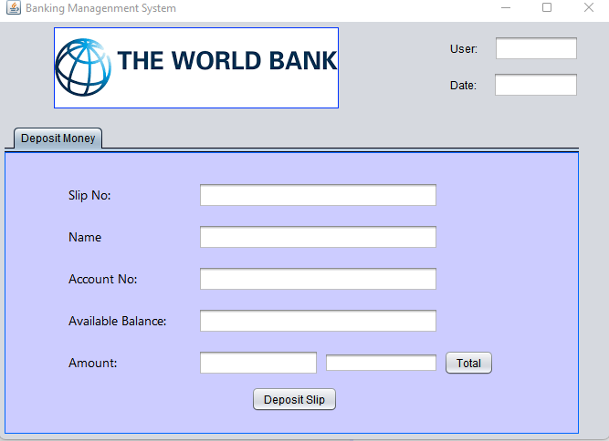

| Use Case 3: Deposit Cheque |
| --- |
| **Scope**: Banking Management System  **Level**: The Customer successfully deposit money in his account through Cheque.  **Primary** **Actor**: Customer ,Cashier  **Stakeholders and Interests**:   * Cashier: Wants accurate, fast entry, and no deposit Payment errors, as cash drawer shortages are deducted from his/her salary. * Customer: Wants deposit and fast service with minimal effort. Wants easily in depositing money in his account. Wants proof of payment to support his side. * Bank Manager: Wants to accurately record transactions and satisfy customer interests. Wants to ensure that Payment Authorization Service payment receivables are recorded. * Maintenance: Wants to be able to quickly perform override operations, and easily debug Cashier, accountant, manager problems. * Bank Server: Wants to receive correct digital transection requests in the correct format and protocol. Wants to accurately store the transection history in the server.   **Preconditions**:  Customer must have a Bank account to deposit money and Cashier is identified and authenticated. |

**Success Guarantee** (or Post conditions):

Deposit money is saved. Deposit money is correctly calculated and deposited. Customer account is updated. Receipt is generated. Deposit authorization approvals are recorded.

**Main Success Scenario (or Basic Flow):**

1. Customer arrives at bank to deposit money.
2. Cashier starts a new payee.
3. Customer enters Customer information in a deposit slip.
4. Customer gave slip to cashier.
5. Cashier counted deposited money
6. System records deposit process and presents total with previous money in account.
7. Cashier generate receipt.
8. Customer get receipt and leave the bank.

**Extensions (or Alternative Flows):**

*a. At any time, System fails:

To support recovery and correct accounting, ensure all transaction sensitive state and events can be recovered from any step of the scenario.

1. Cashier restarts System and requests recovery of prior state.
2. System reconstructs prior state.

2a. System detects anomalies preventing recovery:

* 1. System signals error to the Cashier, records the error, and enters a clean state.
  2. Cashier starts a new payee.

*b. At any time, System fails:

To support recovery and correct accounting, ensure all transaction sensitive state and events can be recovered from any step of the scenario.

1. Cashier restarts System, logs in, and requests recovery of prior state.
2. System reconstructs prior state.

2a. System detects anomalies preventing recovery:

* 1. System signals error to the Cashier, records the error, and enters a clean state.
  2. Cashier starts a new sale.

1a. Customer wants to resume a suspended Cheque.

1. Cashier performs resume operation, and enters the ID to retrieve the process.
2. System displays the state of the resumed process, with subtotal and total money.

2a. Cheque not found.

* 1. System Internet Connection error to the Cashier.
  2. Cashier probably starts new payee and customer re-enters all his/her detail.

**Special Requirements:**

* Process authorization response within 10 seconds 90% of the time.
* Language internationalization on the text displayed. E.g. Urdu, English etc.
* Touch screen UI on a large flat panel monitor. Text must be visible from 10 meter.
* Only one customer can deposit money at a time.
* If system crashes it will automatically restart within 30 second.

**Technology and Data Variations List**:

* Cheque identifier id no entered by keyboard.
* Cheque payment signature captured on paper receipt.
* The Deposit money is counted by banknote Counter.
* Identified Currency by FoxPro software.

**Open Issues:**

* What are the Cheque duration to Deposit Money?
* What customization is needed for different accounts?

**Screen Shots:**

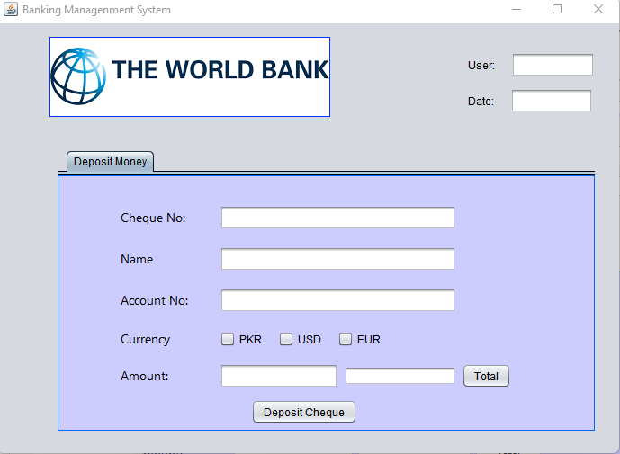

| Use Case UC4: Withdraw Money |
| --- |
| **Scope**: Banking Management System  **Level**: The Customer goal is to Withdraw money from his/her account.  **Primary** **Actor**: Customer ,Cashier  **Stakeholders and Interests**:   * Cashier: Wants accurate, fast entry, and no withdraw Payment errors, as cash drawer shortages are deducted from his/her salary. * Customer: Wants withdraw and fast service with minimal effort. Wants easily in withdrawing money in his account. Wants proof of payment to support his side by receipt. * Bank Manager: Wants to accurately record transactions and satisfy customer interests. Wants to ensure that Payment Authorization Service payment receivables are recorded. * Maintenance: Wants to be able to quickly perform override operations, and easily debug Cashier, accountant, manager problems. * Bank Server: Wants to receive correct digital transection requests in the correct format and protocol. Wants to accurately store the transection history in the server.   **Preconditions**:  Customer must have a Bank account and also have some deposit money in account and Cashier is identified and authenticated. |

**Success Guarantee** (or Post conditions):

Transection is saved. Withdraw money is successfully received. Customer account is updated. Receipt is generated. Withdraw authorization approvals are recorded.

**Main Success Scenario (or Basic Flow):**

1. Customer arrives at bank to withdraw money.
2. Cashier starts a new payee.
3. Customer provide his/her information.
4. Cashier enters Customer information.
5. Customer enter the amount to be withdrawn
6. Cashier repeats counting withdraw money.
7. System presents total with previous money in account.
8. System records Withdraw process.
9. Cashier Generate receipt and gave it to Customer.
10. Customer get receipt and leaves the bank

**Extensions (or Alternative Flows):**

*a. At any time, Manager requests an override operation:

1. System enters Manager-authorized mode.
2. Manager or Cashier performs one Manager-mode operation. e.g., cash balance change, resume a suspended sale on another register, void a sale, etc.
3. System reverts to Cashier-authorized mode.

*b. At any time, System fails:

To support recovery and correct accounting, ensure all transaction sensitive state and events can be recovered from any step of the scenario.

1. Cashier restarts System, logs in, and requests recovery of prior state.
2. System reconstructs prior state.

2a. System detects anomalies preventing recovery:

* 1. System signals error to the Cashier, records the error, and enters a clean state.
  2. Cashier starts a new sale.

1a. Customer or Manager indicate to resume a suspended sale.

1. Cashier performs resume operation, and enters the ID to retrieve the sale.
2. System displays the state of the resumed sale, with subtotal.

2a. Sale not found.

* 1. System signals error to the Cashier.
  2. Cashier probably starts new sale and re-enters all items.

1. Cashier continues with sale (probably entering more items or handling payment).

**Special Requirements:**

* Process authorization response within 10 seconds 90% of the time.
* Language internationalization on the text displayed. E.g. Urdu, English etc.
* Touch screen UI on a large flat panel monitor. Text must be visible from 10 meter.
* Only one customer can withdraw money 50,000 thousand rupees at a time.
* If system crashes it will automatically restart within 30 second.

**Technology and Data Variations List**:

* The Withdraw money is counted by banknote Counter.
* Customer always use the biometric finger print scanner to verify the transection every time he /she Withdraw money.
* Withdraw Money through third party system.

.

**Open Issues:**

- What are the tax law variations?

- Explore the remote service recovery issue.

- What customization is needed for different businesses?

- Must a cashier take their cash drawer when they log out?

- Can the customer directly use the card reader, or does the cashier have to do it?

**Screen Shots:**

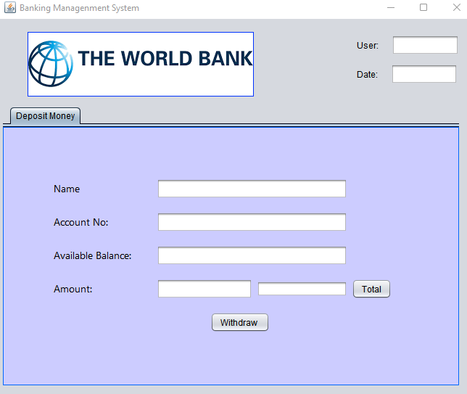

### MUBASHIR AHMED (FA20-BSE-063)

### Use Case 1: Pay Bills

A customer arrives at a bank to pay the bill. The cashier uses the Banking Management System to record each transection of the bill . The system presents the detail of the bill. The Customer provide his/her bill. The Cashier enters the bill information, which the system validates and records. The system updates transection. The customer receives a receipt from the system and then leaves the bank.

### Use Case 2: Transfer Funds

A customer arrives at a bank to transfer the funds . As the bank have already provided him with the facility of depositing slip .The cashier uses the Banking Management System to record each transection of deposited money the Customer will fill his/her deposit slip to transfer funds .Customer will hand-over the slip to the cashier, the cashier will recount the money to verify the amount is correct. The system validates and records. The Customer has successfully transferred money in the account through slip. . The customer receives a receipt from the system and then leaves the bank.

### Use Case 3: Inquiry of balance

AA customer arrives at the bank to check his funds. As the bank has many employees who have access to check the balance. The representee uses the banking management system to check the balance of the customer by inputting his account no. the officer confirms the account name of the customer, then tells him the balance

Student Name 2 (Registration Number 2)

Student Name 3 (Registration Number 3)

## Fully Dressed Use Cases

### Mubashir Ahmed (FA20-BSE-063)

| | Use Case UC 1: Pay Bills | | --- | | **Scope**: Banking Management System  **Level**: The Customer goal is to pay the bills. It could be through deposit slip or Cheque Book.  **Primary** **Actor**: Customer ,Cashier  **Preconditions**: Customer identification is verified through his identity card | |
| --- | --- | --- |

**Success Guarantee** (or Post conditions):

After paying the bill you will be able to see the details of bill payment details on the bill

**Main Success Scenario (or Basic Flow):**

1. Customer along with his bills visit to pay bills
2. Cashier will give information to customer for confirming the details
3. The cashier will check the amount of bill that is default
4. The cashier will enter the customer details and print the details on bill

**Extensions (or Alternative Flows)**

*a. At any time, System fails:

To support recovery and correct accounting, ensure all transaction sensitive state and events can be recovered from any step of the scenario.

1. Cashier restarts System and requests recovery of prior state.
2. System reconstructs prior state.

2a. System detects anomalies preventing recovery:

* 1. System signals error to the Cashier, records the error, and enters a clean state.
  2. Cashier starts a new payee.

*b.Bill is deposit without a detail:

Will we develop some conditions that puts each deposit in some kind of wrapping?

1. If the Customer pays the bill without a customer details, the top payment will be marked with the reference number.
2. The Customer only provide the his reference no to pay bills.

**Special Requirements:**

* UI Should be simpler for the smooth transitions.
* Credit authorization response within 30 seconds 90% of the time.

**Technology and Data Variations List**:

* The Deposit money of the is counted by banknote Counter.
* Identified Currency by FoxPro software.

**Open Issues:**

* Can the Other customer directly use the system to deposit money, or does the accountant have to do it?
* What will be the taxes applied to the customer after limit of the three bills

**Screen Shots:**

| | Use Case UC 2: Transfer Funds | | --- |   **Scope**: Banking Management System  **Level**: Basic Goal  **Primary** **Actor**: Customer ,Cashier  **Stakeholders and Interests**:   * Cashier: Wants accurately transfer funds to the person whom the customer has given the account number * Customer: wants to transfer his funds to the required person * Bank Manager: Wants to accurately record transactions and satisfy customer interests. Wants to ensure that Payment Authorization Service payment receivables are recorded. * Maintenance: Wants to be able to quickly perform override operations, and easily debug Cashier, accountant, manager problems. * Bank Server: Wants to receive correct digital transection requests in the correct format and protocol. Wants to accurately store the transection history in the server.   **Preconditions**:   * The customer must have a valid cnic card to carry this transaction * The customer must have a valid account number to carry the transition |
| --- | --- |

**Success Guarantee** (or Post conditions):

After paying the bill you will be able to see the details of bill payments on the bill

**Main Success Scenario (or Basic Flow):**

1. Cashier will give information to customer for confirming the details of account number
2. The cashier will check the amount of bill that is default
3. The cashier will confirm the bank details to the customer

**Extensions (or Alternative Flows):**

*a. At any time, System fails:

To support recovery and correct accounting, ensure all transaction sensitive state and events can be recovered from any step of the scenario.

1. Cashier restarts System and requests recovery of prior state.
2. System reconstructs prior state.

2a. System detects anomalies preventing recovery:

* 1. System signals error to the Cashier, records the error, and enters a clean state.
  2. Cashier starts a new payee.

*b. Money cannot deposit with Wrong detail:

If the Customer transferred funds with wronged customer details, the top payment will not be marked.

* Money cannot be transfered if the customer is not given the proper detail of his accounts to where transfer money. To solve this the system must gave the user another slip the rewrite the information again

**Special Requirements:**

* Process authorization response within 10 seconds 90% of the time.
* Language internationalization on the text displayed. E.g. Urdu, English etc.
* Touch screen UI on a large flat panel monitor. Text must be visible from 10 meter.
* Only one customer can deposit money at a time.
* If system crashes it will automatically restart within 30 second.

**Technology and Data Variations List**:

* The transferred money is counted by banknote Counter.
* Identified Currency by FoxPro software.
* transferred Money through third party system.

**Open Issues:**

* What are the taxes that will apply on my account through the year?
* Explore the remote service recovery issue.
* Must a cashier take their cash drawer when they log out?
* Can the Other customer directly use the system to deposit money, or does the accountant have to do it?

**Screen Shots:**

| Use Case 3: Balance Inquiry |
| --- |
| **Scope**: Banking Management System  **Level**: The Customer successfully inquire the balance through account number  **Primary** **Actor**: Customer ,Cashier  **Stakeholders and Interests**:   * CUSTOMER: The customer must have valid account number to check his balance. * Bank Server: Bank Server must have stable internet connection for checking the balance of customer. * Bank Manager: Wants to accurately record transactions and satisfy customer interests. Wants to ensure that Payment Authorization Service payment receivables are recorded. * Maintenance: Wants to be able to quickly perform override operations, and easily debug Cashier, accountant, manager problems. * Bank Server: Wants to receive correct digital transection requests in the correct format and protocol. Wants to accurately store the transection history in the server.   **Preconditions**:  The customer must have valid account number to check his balance |

**Success Guarantee** (or Post conditions):

The customer must have valid account number to check his balance

**Main Success Scenario (or Basic Flow):**

* System shall show the details of the account funds through account number
* System should show the account holder name
* Customer arrives at bank to inquiry funds in his account.
* Customer enters Customer information to check the funds.

**Extensions (or Alternative Flows):**

*a. At any time, System fails:

To support recovery and correct accounting, ensure all transaction sensitive state and events can be recovered from any step of the scenario.

1. Cashier restarts System and requests recovery of prior state.
2. System reconstructs prior state.

2a. System detects anomalies preventing recovery:

* 1. System signals error to the Cashier, records the error, and enters a clean state.
  2. Cashier starts a new payee.

*b. At any time, System fails:

To support recovery and correct accounting, ensure all transaction sensitive state and events can be recovered from any step of the scenario.

1. Cashier restarts System, logs in, and requests recovery of prior state.
2. System reconstructs prior state.

2a. System detects anomalies preventing recovery:

* 1. System signals error to the Cashier, records the error, and enters a clean state.
  2. Cashier starts a new sale.

**Special Requirements:**

* Process authorization response within 10 seconds 90% of the time.
* Language internationalization on the text displayed. E.g. Urdu, English etc.
* Touch screen UI on a large flat panel monitor. Text must be visible from 10 meter.
* Only one customer can deposit money at a time.
* If system crashes it will automatically restart within 30 second.

**Technology and Data Variations List**:

* Cheque identifier id no entered by keyboard.
* Cheque payment signature captured on paper receipt.
* The Deposit money is counted by banknote Counter.
* Identified Currency by FoxPro software.

**Open Issues:**

* What are the Cheque duration to Deposit Money?
* What customization is needed for different accounts?

**Screen Shots:**

### Rahim Khan [ 050]

### **Use case name:** Insurance

**Scope:** Banking Management System

**Level**: the customer insurance is done.

**Primary Actor**: Customer, insurance officer

**Stakeholders and Interests:**

- Customer: Wants to get insurance for car, health etc.

-Loan Officer: He will explain different plans and offers to you and complete your insurance.

- Deposit Authorization Service: Will check whether you’re paying your installments on time or not.

**Preconditions:** User must pay the installments on time.

**Success Guarantee**: select the type of insurance you want and the insurance will done.

**Main Success Scenario:**

1. Customer arrives at bank for insurance.
2. Insurance officer tell him about the plans.
3. Customer select the plan he wants.
4. Officer inquires about his balance score.
5. If everything is okay, then the insurance is done.

**\*b. If the loan in not approved:**

If the customer balance history is not good then his insurance can’t be done and his request will be not deined.

**Special Requirements:**

- Touch screen UI on a large flat panel monitor. Text must be visible from 1 meter.

- Process authorization response within 30 seconds 80% of the time.

- Somehow, we want robust recovery when access to remote services such the inventory system is failing.

- Language internationalization on the text displayed.

- Pluggable business rules to be insertable at steps 3 and 7

.

**Open Issues:**

- What are the tax law variations?

- Explore the remote service recovery issue.

- What customization is needed for different businesses?

- Must a cashier take their cash drawer when they log out?

- Can the customer directly use the card reader, or does the cashier have to do it?

**Screen Shots:**

